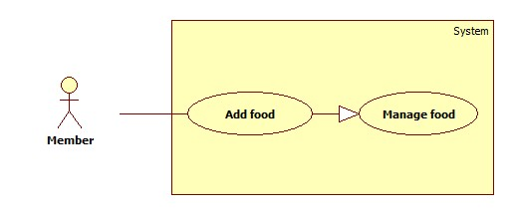

**Use Case Specification**

|  |  |  |  |
| --- | --- | --- | --- |
| **USE CASE - M01** | | | |
| **Use Case No.** | M01 | **Use Case Version** |  |
| **Use Case Name** | Add food | | |
| **Author** | Truong Thanh Lam | | |
| **Date** | 25/01/2016 | **Priority** | High |
| **Actor:**   * Member   **Summary:**   * This use case allows members to add food. This use case is applied for both mobile application and web interface.   **Goal:**   * Member can use this method to add food to his/her fridge after acquiring food in reality.   **Triggers:**   * Member sends Add food command   **Preconditions:**   * Actor must logged in with role Member   **Post Conditions:**   * Success: New food is added to the system * Fail: Error message is shown   **Main Success Scenario:**   |  |  |  | | --- | --- | --- | | **Step** | **Actor Action** | **System Response** | | **1** | Member goes to Add food view | System shows view and requires new food information:  - Name: free text input, required, length [2,30]  - Quantity: free text input, integer value (0,1000]  - Unit: choose from list  - Expired date: date, required, must be later than or equals current date  - Notification date: number, required. (default value is 3). | | **2** | Member inputs new food information  [Alternative 1] |  | | **3** | Member sends Add food command | New food is added to the system  [Exception 1, 2, 3] |   **Alternative Scenario:**   |  |  |  | | --- | --- | --- | | **No** | **Actor Action** | **System Response** | | **1** | Member selects Scan barcode option  Member uses camera to scan barcode  Member inputs remaining information: Quantity, Unit, Expired date, Notification date | System activates camera to scan food’s barcode  System recognizes barcode and fills food name |   **Exception**   |  |  |  | | --- | --- | --- | | **No** | **Cause** | **System Response** | | **1** | Member inputted food name with inappropriate length | System shows error message: “Food name must be between 2 and 30 characters.” | | **2** | Member inputted quantity with a non-number value or a value less than 0 or greater than 1000 | System shows error message: “Quantity must be greater than 0 and less or equals to 1000.” | | **3** | Member inputted expired date sooner than current date | System shows error message: “Expired date must be later or equals current date.” |   **Relationships: N/A**  **Business Rules:**   * Unit can be kilogram, gram, can, bottle, piece, box... or user manually input. * After adding, food has status “Pending” | | | |

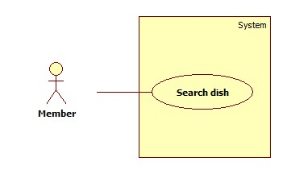

**Use Case Specification**

|  |  |  |  |
| --- | --- | --- | --- |
| **USE CASE - M02** | | | |
| **Use Case No.** | M02 | **Use Case Version** |  |
| **Use Case Name** | Search dish | | |
| **Author** | Truong Thanh Lam | | |
| **Date** | 25/01/2016 | **Priority** | Normal |
| **Actor:**   * Member   **Summary:**   * This use case allows members to search dishes by name. This use case is applied for both mobile application and web interface.   **Goal:**   * Member can use this method to search for dishes. After inputting dish name, some suggested dishes are displayed.   **Triggers:**   * Member sends Search dish command   **Preconditions:**   * Actor must logged in with role Member   **Post Conditions:**   * Success: Search result is shown   **Main Success Scenario:**   |  |  |  | | --- | --- | --- | | **Step** | **Actor Action** | **System Response** | | **1** | Member goes to Search dish view | System shows view and requires search information:  - Search text: free text input, required, length [2,50] | | **2** | Member inputs dish name and sends Search dish command | System searches dishes based on name and displays result  [Alternative 1] |   **Alternative Scenario:**   |  |  |  | | --- | --- | --- | | **No** | **Actor Action** | **System Response** | | **1** |  | If no record is matched, system displays message “No record is matched.” |   **Exception: N/A**  **Relationships:**   * View recipe   **Business Rules:**   * Searching by comparing search text and dish name. If dish name contains search text, the dish is selected. * Search result is sorted by founded order. * Search result is displayed as a grid contains dishes’ names, short description and option for Member to View recipe | | | |

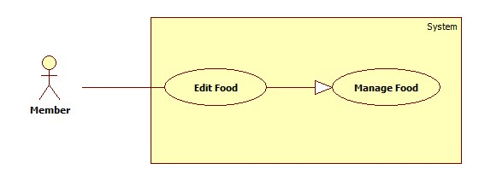

**Use Case Specification**

|  |  |  |  |
| --- | --- | --- | --- |
| **USE CASE - M03** | | | |
| **Use Case No.** | M03 | **Use Case Version** |  |
| **Use Case Name** | Edit food | | |
| **Author** | Truong Thanh Lam | | |
| **Date** | 15/02/2016 | **Priority** | Normal |
| **Actor:**   * Member   **Summary:**   * This use case allows members to edit foods’ information. This use case is applied for both mobile application and web interface.   **Goal:**   * Member can use this method to edit food information in his/her fridge when changes occured.   **Triggers:**   * Member sends Edit food command   **Preconditions:**   * Actor must logged in with role Member   **Post Conditions:**   * Success: Foods’ information is saved to the system * Fail: Error message is shown   **Main Success Scenario:**   |  |  |  | | --- | --- | --- | | **Step** | **Actor Action** | **System Response** | | **1** | Member goes to Manage food view | System shows a grid contains all of member’s foods with the following information:  - Name: uneditable  - Quantity: editable, free text input, integer value (0,1000]  - Unit: editable, choose from list  - Expired date: editable, date, required, must be later than or equals current date  - Notification date: editable, number, required. (default value is 3). | | **2** | Member inputs necessary changes |  | | **3** | Member sends Edit food command | Food’s information is saved to the system  [Exception 1, 2] |   **Alternative Scenario: N/A**  **Exception**   |  |  |  | | --- | --- | --- | | **No** | **Cause** | **System Response** | | **1** | Member inputted quantity with a non-number value or a value less than 0 or greater than 1000 | System shows error message: “Quantity must be greater than 0 and less or equals to 1000.” | | **2** | Member inputted expired date sooner than current date | System shows error message: “Expired date must be later or equals current date.” |   **Relationships: N/A**  **Business Rules:**   * Unit can be kilogram, gram, can, bottle, piece, box... or user manually input. | | | |

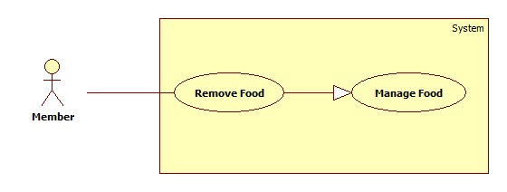

**Use Case Specification**

|  |  |  |  |
| --- | --- | --- | --- |
| **USE CASE - M04** | | | |
| **Use Case No.** | M04 | **Use Case Version** |  |
| **Use Case Name** | Remove food | | |
| **Author** | Truong Thanh Lam | | |
| **Date** | 15/02/2016 | **Priority** | Normal |
| **Actor:**   * Member   **Summary:**   * This use case allows members to remove food. This use case is applied for both mobile application and web interface.   **Goal:**   * Member can use this method to remove food from his/her fridge when, for example, food is expired or consumed.   **Triggers:**   * Member sends Remove food command   **Preconditions:**   * Actor must logged in with role Member   **Post Conditions:**   * Success: Food is removed from the system   **Main Success Scenario:**   |  |  |  | | --- | --- | --- | | **Step** | **Actor Action** | **System Response** | | **1** | Member goes to Manage food view | System shows a grid contains all of member’s foods with the following information:  - Name: uneditable  - Quantity: editable, free text input, integer value (0,1000]  - Unit: editable, choose from list  - Expired date: editable, date, required, must be later than or equals current date  - Notification date: editable, number, required. (default value is 3). | | **2** | Member chooses food and sends Remove food command | Remove selected food from the system |   **Alternative Scenario: N/A**  **Exception: N/A**  **Relationships: N/A**  **Business Rules:**   * Unit can be kilogram, gram, can, bottle, piece, box... or user manually input. | | | |



**Use Case Specification**

|  |  |  |  |
| --- | --- | --- | --- |
| **USE CASE - M05** | | | |
| **Use Case No.** | M05 | **Use Case Version** |  |
| **Use Case Name** | View Recipe | | |
| **Author** | Truong Thanh Lam | | |
| **Date** | 15/02/2016 | **Priority** | Normal |
| **Actor:**   * Member   **Summary:**   * This use case allows members to view the content of a recipe. This use case is applied for both mobile application and web interface.   **Goal:**   * Member can use this method to view an interested recipe’s content, steps and related images.   **Triggers:**   * Member sends View recipe command   **Preconditions:**   * Actor must logged in with role Member   **Post Conditions:**   * Success: Recipe content is shown   **Main Success Scenario:**   |  |  |  | | --- | --- | --- | | **Step** | **Actor Action** | **System Response** | | **1** | From Search dish result or from suggestion, member selects a recipe and sends View recipe command | System shows recipe content with the following information:  - Introduction/Description  - The steps to make the dish  - Images |   **Alternative Scenario: N/A**  **Exception: N/A**  **Relationships:**  - Search dish  - Send suggestion  - Add favorite dish  **Business Rules: N/A** | | | |



**Use Case Specification**

|  |  |  |  |
| --- | --- | --- | --- |
| **USE CASE - M06** | | | |
| **Use Case No.** | M06 | **Use Case Version** |  |
| **Use Case Name** | Add favorite dish | | |
| **Author** | Truong Thanh Lam | | |
| **Date** | 15/02/2016 | **Priority** | Normal |
| **Actor:**   * Member   **Summary:**   * This use case allows members to add a dish to favorite list. This use case is applied for both mobile application and web interface.   **Goal:**   * Member can use this method to make his/her favorite list. This is also a way to gain quick access to dishes they usually need.   **Triggers:**   * Member sends Add favorite dish command   **Preconditions:**   * Actor must logged in with role Member   **Post Conditions:**   * Success: Favorite dish is added associated with the member   **Main Success Scenario:**   |  |  |  | | --- | --- | --- | | **Step** | **Actor Action** | **System Response** | | **1** | From a recipe content view, member sends Add favorite dish command | System adds the selected dish to member’s favorite list |   **Alternative Scenario: N/A**  **Exception: N/A**  **Relationships:** View recipe  **Business Rules: N/A** | | | |